Development Courses
2019
Updated March 2019

Introduction to Development Courses

Subject matter for each class has been specifically identified to help develop faith in, and knowledge of, our Lord and Savior. The format will be presented in four quarters through the year; several different classes will be offered each quarter, and class attendees will have an opportunity to learn from different instructors, meet new people in the different classes, and enjoy a variety of Biblically-based subject matter.
And it is my prayer that your love may abound more and more, with knowledge
and all discernment... Philippians 1:9

This initiative is part of our Care, Connect and Challenge mission, making disciples who make disciples, and is consistent with the Micro Church program which is designed to encourage and
challenge believers to live out their faith and share
the Good News.

1 Peter 3:15- always be ready to give an answer to anyone who asks about the hope you possess.

Table of Contents

2nd Quarter – Spring Courses
April 7-June 30, 2019
No Classes on Easter Sunday, April 21st

- Book of Colossians

- How to Get Out of My Own Way
- Getting to Know #cicerofam (in May)
- Christian Standard Bible Lesson Commentary
- Reasons to Believe
- Titus - Women’s Ministry

Map of Cicero Christian Church
Kids & Student Services
CCC Leadership & Support Staff

Christian Education Teachers
Heart of why you teach
Andy Gable - I consider it an honor to have a role in the discipleship process of other people. I enjoy teaching, not just to impart knowledge to others, but helping them process new learning in a way that leads to life change and a deeper connection to God and their neighbors.

Keith Schoettmer - I’ve been teaching Sunday school at Cicero Christian Church for over 10 years. I love the challenge of keeping class interesting and sharing God's word with other Christians, regardless of where they are in their walk. I firmly believe that the only way we can truly appreciate and understand the heart of Christ is to dive into His word with regular, disciplined study.
Gino Small - The words of Paul in Romans 1 describes for me the reason I take time to facilitate in a classroom setting. Romans 1:11-12, “ I long to see you so that I may impart to you some spiritual gift to make you strong-that is, that you and I may be mutually encouraged by each other’s faith.”

John Knapp – I have enjoyed teaching SS for years the first thing I do is to pray for the Holy Spirit to guide and direct me that I will be able to reach out and touch someone with the Word of God.

Spring Quarter April 28-June 2, 2019
Book of Colossians (6 weeks)

Led by: Keith Schoettmer
9a- first service in room 107
Summary of the Class
Written by the Apostle Paul from a prison cell, the book of Colossians is a letter of encouragement about the certainty of our faith. The early church was being infiltrated with false teachings and causing discord among believers. Paul explains that these teachings are totally empty compared to the absolute supremacy and sole sufficiency of Christ. He then finishes the letter with practical considerations of what the divinity of Jesus should mean to all believers.
In this class we will bring Colossians to life as it pertains to our world today. The challenges that diluted the church of Colossae are like those which the church faces today. This class participation study includes lively discussions on the applicability of Paul’s directives to the Church today. Join us as we dive deeper into the Word of God!

Spring Quarter May 12- June 30, 2019

How to Get Out of My Own Way (8 weeks)

Led by: Andy Gable
9a – first service in room 133
Summary of the Class
Temptations, bad habits, and personal struggles... How do we deal with these obstacles to a deepening relationship and reliance on Jesus? Jesus invites us to come closer, but our habits and struggles seem to keep getting in the way. What are we to do?
C.S. Lewis had a keen understanding of how temptation and personal struggles keep us from fully engaging in our faith and following Jesus. Two of his works, The Screwtape Letters and The Great Divorce, shine a light on these vices and help guide us in getting out of our own way as we seek to follow Jesus.

Spring Quarter May 5-26, 2019
Getting to Know #cicerofam (4 weeks)
9a – first service in room 213
Summary of the Class
This 4-week course introduces people to Cicero Christian Church and provides an overview of what matters most to our church and leadership team. It also gives some intentional next steps into discovering life with Jesus as well as what it means to be a part of the #cicerofam.

Week One: #whatweareabout
Discover our vision, mission, values, and strategy.

Week Two: #whatwebelieve
Discover our foundational beliefs.

Week Three: #joiningGod’sfam
Discover the next steps to a saving relationship with God.

Week Four: #joiningcicerofam
Discover the next steps of faith in Christ and serving alongside us here at CCC.

Next class offered in July 2019

Spring Quarter April 7-June 30, 2019
Standard Lesson Commentary (12 weeks)

Led by: John Knapp
10:30a- second service in room 133

No Classes on Easter Sunday, April 21st
Summary of the Class
The Standard Lesson Quarterly surveys the Bible in six years, providing solid adult Bible study based on International Sunday School Lessons/Uniform Series. Each quarter contains 13 weeks of lessons, including verse-by-verse Bible exposition, discussion questions, and ready to use resources to enhance study.

Spring Quarter April 14-June 30, 2019
Reasons to Believe (11 weeks)

Led by: Gino Small
10:30a - second service in room 107

No Classes on Easter Sunday, April 21st
Summary of the Class
Do you or someone you care about struggle with questions and doubts about God, science, or the Bible? Questions and doubts are a normal part of life, but when they are left alone, they foster feelings that God and the Bible are untrustworthy for guiding our lives. We need to bring doubts out into the light and engage them in an honest search for the truth.
This class will deal with many of the doubts about faith, God, and science in our world today. What does the evidence show about the reliability of God and His Word? We want to shine a light on the doubts and help you “be prepared to give an answer to everyone who asks you to give the reason for the hope that you have.” (1 Peter 3:15)

Other Classes Offered
in the Spring Quarter
Titus - Women’s Ministry (4 weeks)
Led by: Deb Alley on Sunday, Jennifer Peters on Tuesday, & Carol Emmert on Thursday
Begins Sundays 4/7-5/5 at 9a (skip 4/21) room 133
Tuesdays 4/9-5/7 at 10a (skip 4/23) room 107
Thursdays 4/11-5/9 at 7p (skip 4/25) room 107
Summary of the Class
In this Book of the Bible series, Chip Ingram unpacks the book of Titus. He challenges us to display the gospel in our lives through doing good. We do good works not to earn God’s favor, but as a result of God’s favor. When the gospel has truly taken root in our lives, it produces the fruit of godliness. As we pass these things on to future generations, the Church stands in bright contrast to the darkness of the world.

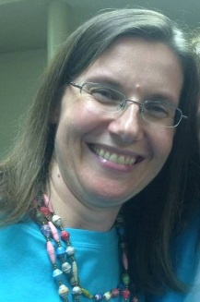

Deb Alley
Jennifer Peters
Carol Emmert

Next Gen Services

Kids: Infants - Kindergarten
The Treehouse, birth through Kindergarten,
available both 9a & 10:30a
Grades 1- 5
9a Sunday School
Grades 1-2 room 112
Grades 3-5 room 114
10:30a Worship
Clubhouse for grades 1-5, room 116/117
Students: (Grades 6 - 12)
9a No Sunday School
10:30a MvMnt for Students in grades 6-12, will worship in the Loft, room 218, upstairs

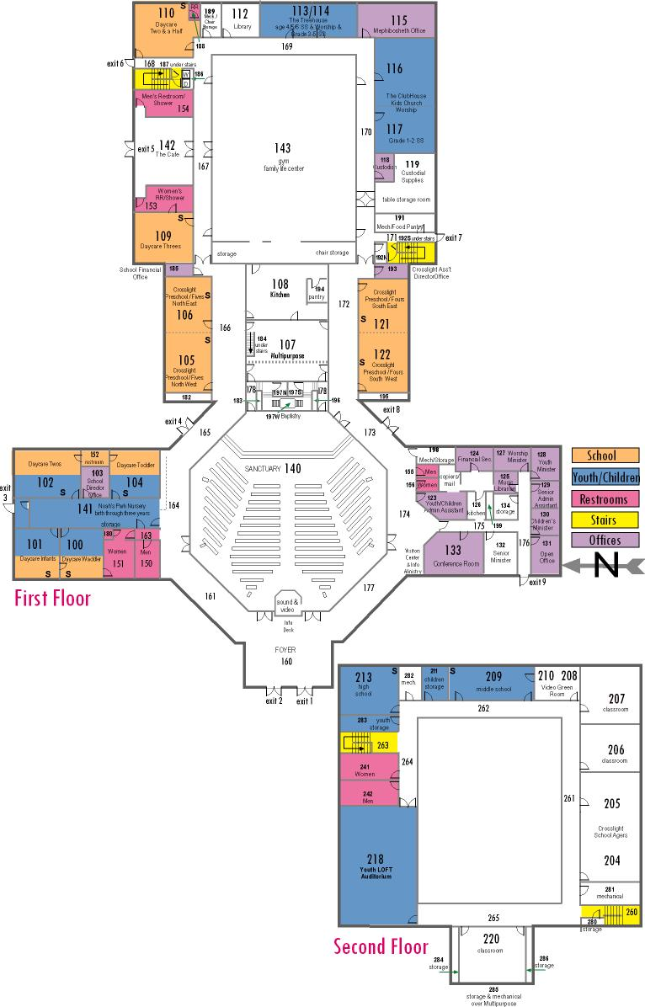
Map of CCC Classrooms

CCC Leadership & Support Staff

2019 Church Elders
Mark Fisher, cabinet chair…………….....…...…..317-984-2000
Mike House………………………………….…......317-439-9803
Dan Conder………………………...……….....…...317-758-6382
Jay St.Peters…………………………………….…317-450-3198
Keith Schoettmer…………….…………..……...…765-675-6822
Mike Hutson …………………………………….…on sabbatical
Pastoral & Support Staff
Senior Pastor Adam Colter adam@cicerochristianchurch.org
Associate Pastor Andy Gable andy@cicerochristianchurch.org
Worship Pastor Zack Schuyler
zack@cicerochristianchurch.org
Next Generation Director & High School Pastor Justin Pollock justin@cicerochristianchurch.org
Middle School Pastor Katie Smith
katie@cicerochristianchurch.org
Children’s Pastor & Administrative Assistant Amber Hawkins
amber@cicerochristianchurch.org
Next Generation Volunteer Coordinator Kristyn Cooper kristyn@cicerochristianchurch.org
Christian Counselor Charley Gerber
ccscharley@aol.com or 765-289-1631
Financial Secretary Sherry Strauss
sherry@cicerochristianchurch.org
Senior & Associate Pastor Administrative Asst. Jenni Roosa
jenni@cicerochristianchurch.org
Administrative Assistant Lisa Jamison lisa@cicerochristianchurch.org
Administrative Assistant Holly Eldredge
holly.eldredge@halo.com

