Development Courses July 7- Sept 29
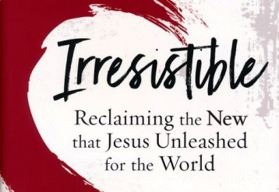
Courses Starting July 7th
Irresistible – Led by Jason Eyers
6 week Class ~ 1st Hour in Room 133
Once there was a version of our faith that was practically . . . irresistible. What did first-century Christians know that we don't? How do we embrace a version of faith that initiated a chain of events resulting in the most significant and extensive cultural transformation the world has ever seen. A version we must embrace if we are to be salt and light in an increasingly savorless and dark world.

Walking In The Spirit – Led by Jim Doyle
8-week Class ~ 1st Hour in Room 107
Too often we think of the Holy Spirit as God's presence working in the background or behind the scenes, but God intends for us to have a daily relationship in which we partner with the Holy Spirit as we follow Him. Join us as we learn to walk in the Spirit daily.
Standard Lesson Commentary – Led by John Knapp
12-week Class ~ 2nd Hour in Room 133
The Standard Lesson Quarterly surveys the Bible in six years, providing solid adult Bible study based on International Sunday School Lessons/Uniform Series. Each quarter contains 13 weeks of lessons, including verse-by-verse Bible exposition, discussion questions, and ready to use resources to enhance study.
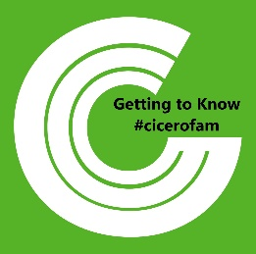
Getting to Know the #Cicerofam – Led by Andy Gable
4-week Class ~ 2nd Hour in Room 107
This course introduces people to Cicero Christian Church and provides an overview of what matters most to our church and leadership team. It also gives some intentional next steps into discovering life with Jesus as well as what it means to be a part of the #cicerofam.
Development Courses July 7- Sept 29
Courses Starting July 7th
Irresistible – Led by Jason Eyers
6 week Class ~ 1st Hour in Room 133
Once there was a version of our faith that was practically . . . irresistible. What did first-century Christians know that we don't? How do we embrace a version of faith that initiated a chain of events resulting in the most significant and extensive cultural transformation the world has ever seen. A version we must embrace if we are to be salt and light in an increasingly savorless and dark world.

Walking In The Spirit – Led by Jim Doyle
8-week Class ~ 1st Hour in Room 107
Too often we think of the Holy Spirit as God's presence working in the background or behind the scenes, but God intends for us to have a daily relationship in which we partner with the Holy Spirit as we follow Him. Join us as we learn to walk in the Spirit daily.
Standard Lesson Commentary – Led by John Knapp
12-week Class ~ 2nd Hour in Room 133
The Standard Lesson Quarterly surveys the Bible in six years, providing solid adult Bible study based on International Sunday School Lessons/Uniform Series. Each quarter contains 13 weeks of lessons, including verse-by-verse Bible exposition, discussion questions, and ready to use resources to enhance study.
Getting to Know the #Cicerofam – Led by Andy Gable
4-week Class ~ 2nd Hour in Room 107
This course introduces people to Cicero Christian Church and provides an overview of what matters most to our church and leadership team. It also gives some intentional next steps into discovering life with Jesus as well as what it means to be a part of the #cicerofam.
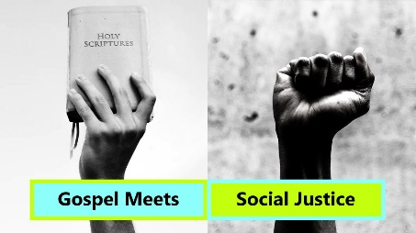
Course Starting August 4th
Where The Gospel Meets Social Justice – Led by Andy Gable & Debbie Reeves, 8-week Class ~ 2nd Hour in Room 107
What does it mean to do "justice" in the Kingdom of God? Social Justice is a vital conversation in today's world, but what exactly does "social justice" mean and more importantly what does it look like in God's Kingdom? Join us as we learn what it means to live out grace & truth and demonstrate love to those who are oppressed in our world.
Courses Starting September 8th
The Emotionally Healthy Woman – Led by the Women’s Ministry
10-week Class ~ 1st Hour in Room 107
Stop pretending everything is fine and change your life. According to Geri Scazzero, the journey to emotional health begins with quitting. When you quit those things that are damaging your soul or the souls of others, you are freed up to choose other ways of being and relating that are rooted in love and lead to life.
Grounded in Scripture, this eight-session video-based study is filled with Bible study and personal applications that will help you discuss and learn to live out the teaching on the corresponding video. If you're ready to prayerfully make the kinds of outrageous decisions needed to become emotionally healthy, this study is for you.
Getting to Know the #Cicerofam – Led by Mark Fisher
4-week Class ~ 1st Hour in Room 213
This course introduces people to Cicero Christian Church and provides an overview of what matters most to our church and leadership team. It also gives some intentional next steps into discovering life with Jesus as well as what it means to be a part of the #cicerofam.

Course Starting August 4th
Where The Gospel Meets Social Justice – Led by Andy Gable & Debbie Reeves, 8-week Class ~ 2nd Hour in Room 107
What does it mean to do "justice" in the Kingdom of God? Social Justice is a vital conversation in today's world, but what exactly does "social justice" mean and more importantly what does it look like in God's Kingdom? Join us as we learn what it means to live out grace & truth and demonstrate love to those who are oppressed in our world.
Courses Starting September 8th
The Emotionally Healthy Woman – Led by the Women’s Ministry
10-week Class ~ 1st Hour in Room 107
Stop pretending everything is fine and change your life. According to Geri Scazzero, the journey to emotional health begins with quitting. When you quit those things that are damaging your soul or the souls of others, you are freed up to choose other ways of being and relating that are rooted in love and lead to life.
Grounded in Scripture, this eight-session video-based study is filled with Bible study and personal applications that will help you discuss and learn to live out the teaching on the corresponding video. If you're ready to prayerfully make the kinds of outrageous decisions needed to become emotionally healthy, this study is for you.
Getting to Know the #Cicerofam – Led by Mark Fisher
4-week Class ~ 1st Hour in Room 213
This course introduces people to Cicero Christian Church and provides an overview of what matters most to our church and leadership team. It also gives some intentional next steps into discovering life with Jesus as well as what it means to be a part of the #cicerofam.

